You can choose to submit either A5 (worth 150 points), AD5 (worth 180), or both (worth 180) for this assignment you will get a score for the assignment either 150 points base or 180 points base.

A5

Write a program that illustrates rethrowing an exception. Define methods CISP401Method and CISP401Method2. Method CISP401Method2 should initially throw an exception. Method CISP401Method should call CISP401Method2, catch the exception and rethrow it. Call CISP401Method from method main, and catch the rethrown exception. Print the stack trace of this exception.
The following is the result of the program.
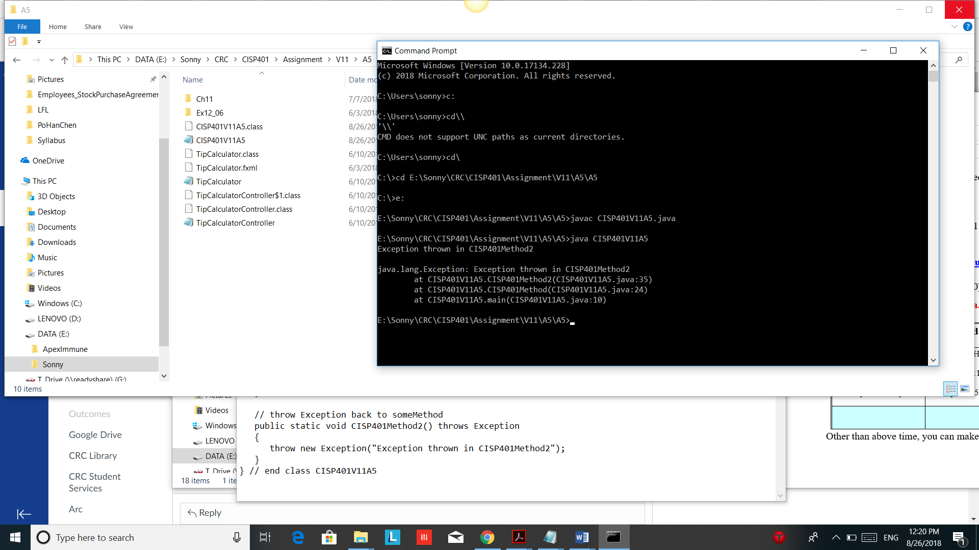

You can fine the needed techniques in chapter 1~ 11. You can also use more advance skills to do this assignment.
This assignment comes with a CISP401V11A5.zip file. It includes one file (CISP401V11A5.class.) It is an executable files. You can place them in a sub folder (directory). Bring up a command prompt and go to the sub directory, type “java CISP401V11A5 “ in the sub directory and hit “Enter” key. You should see the program run and generate the above picture result.

Please document the file properly and zip your .java file into a proper named zip file for an assignment (refer to the assignment section of the class syllabus) and submit it to the A5 folder of the Canvas Website.

Worth 150 points

AD5
Modify the Tip Calculator app in section 12.5(attached) to allow the user to enter the number of people in the party . Calculate and display the amount owned by each person if the bill were to be split evenly amount the party member.
The following are some of the feature:
When we bring up the program we should see a display like the picture on the right column. | 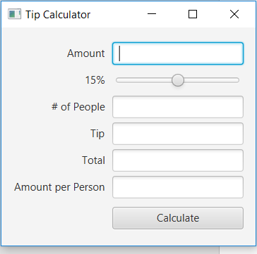
After we provide proper amount and number of people in the respective field we can click “Calculate button to generate a result. | 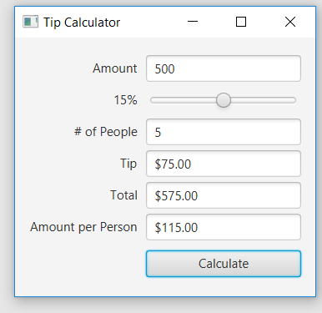
We can only adjust amount, percentage, and # of People. Data of Tip, Total, and Amount per Person can only be generated by the program. We can not delete or adjust the data through any input devices. | 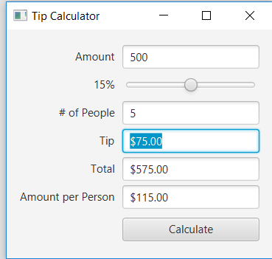
When you enter not a number into the “Amount” field or/and “# of People” field, the “Amount” field should have data “Enter amount” and highlighted. | 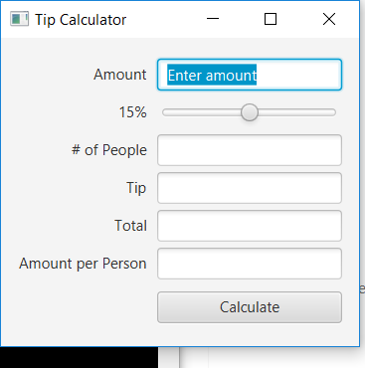
Please review the textbook material and understand then. You can also use more advance skills to do this assignment.
This assignment comes with a CISP401V10AD5.zip file. It includes three .class files and one .fxml file . All of the .class files are executable files. You can place them in a sub folder (directory). Bring up a command prompt and go to the sub directory, type “java TipCalculator“ in the sub directory and hit “Enter” key. You should see the program run . Please try the program thoroughly to understand the requirements.
This program comes with TipCalculator.zip file. It has the textbook example program.
Please document the files properly and zip your files for this assignment into a proper named zip file for an advance assignment (refer to the assignment section of the class syllabus) and submit it to the A5 folder of the Canvas Website.

Worth 180 points

